# PubnubStep

**Objective:**

It is used to publish a message in channel, so subscriber can subscribe to that channel to get notifications.

**Attributes:**

|  |  |
| --- | --- |
| **Attributes** | **Description** |
| channel | To enter the channel name |
| message | To enter a message which subscriber will get as notification |
| plugin_name | To connect with pubnub server based on the credentials |
| value_type | To select type as free marker template or handlebar |
| auth_key | Used to enter authentication key |

**Sample config.json:**

{

"server": {},

"workflows": [

{

"id": "pubnubtest",

"name": "pubnub",

"trigger": "rest",

"expression": "/pubnub_notifications",

"method": "GET",

"steps": [

{

"id": "1",

"type": "pubnub-step",

"channel": "mychannel",

"message":"hello pubnub",

"plugin_name":"pubnub_plugin",

"auth_key":"mykey1",

"next": {

"success": "success_msg",

"failure":"hangup"

}

},

{

"id":"success_msg",

"type":"set-var",

"name": "success",

"value": "notification successfully published",

"next":{

"success":"success"

}

},

{

"id": "success",

"type": "send",

"variable_name": "success"

}

]

}

],

"plugins": [

{

"id": "pubnub_plugin",

"type": "pubnub-plugin",

"name": "pubnub_plugin",

"subscribe_key":"sub-c-321882d0-d769-11e8-a9d8-c64261e97101",

"publish_key":"pub-c-2412ebb1-9b20-498f-90b0-9e1787e7c717",

"secret_key":"sec-c-Nzg2NjFhNzMtZDM1Yy00YjUyLWFlMjMtMDJmY2ZmNWIyMDA4"

}

],

"filters": []

}

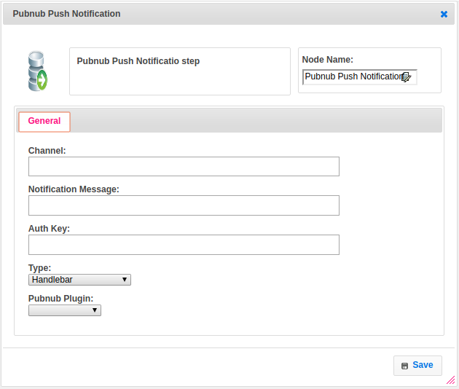

**Executor Description:**

In executor class first will subscribe the channel then authenticate the channel based on auth_key, after authentication will publish message to respective channel nad returns status as success otherwise it will throws exception as unable to publish message.